Delivery of Sprint-4

WEB UI CREATION

|  |  |
| --- | --- |
| Date | 16 Nov 2022 |
| Team ID | PNT2022TMID48082 |
| Project Name | Smart Waste Management System For Metropolitan Cities |

**TASK:**

***We can develop a web ui to make the user interact with the help of workflow for iot scenarios using Node-Red .***

# PYTHONCODE FOR DETECTING BIN LEVEL AND DISPLAYING IT IN IBM CLOUD:

#IBM Watson IOT Platform

#pip install wiotp-sdk

import wiotp.sdk.device

import time

import random

import requests

import math

myConfig = {

"identity": {

"orgId": "4raljz",

"typeId": "pythoncode",

"deviceId":"2811"

},

"auth": {

"token": "912419104024"

}

}

def myCommandCallback(cmd):

print("Message received from IBM IoT Platform: %s" % cmd.data['command'])

m=cmd.data['command']

client = wiotp.sdk.device.DeviceClient(config=myConfig,logHandlers=None)

client.connect()

while True:

res = requests.get('https://ipinfo.io/')

data = res.json()

loc = data['loc'].split(',')

theta = random.uniform(0,2*math.pi)

area = (0.05**2)*math.pi

radius = math.sqrt(random.uniform(0,area/math.pi))

latitude,longitude = [float(loc[0])+radius*math.cos(theta), float(loc[1])+radius*math.sin(theta)]

latitude=random.uniform(27.2046,125.25)

longitude=random.uniform(77.4977,100.1526)

binlevel=random.randint(10,100)

binweight=random.randint(10,100)

if binlevel >= 90:

myData={'latitude':latitude,

'longitude':longitude,'binlevel':binlevel,'binweight':binweight}

client.publishEvent(eventId="status",

msgFormat="json", data=myData, qos=0, onPublish=None) ##print("Published data Successfully: %s", myData)

print("BIN IS FULL..TIME TO EMPTY IT!!!!\n",myData)

client.commandCallback = myCommandCallback

time.sleep(3)

else :

print("BIN IS IN NORMAL LEVEL")

time.sleep(3)

client.disconnect()

# IBM WATSON IOT PLATFORM OUTPUT:

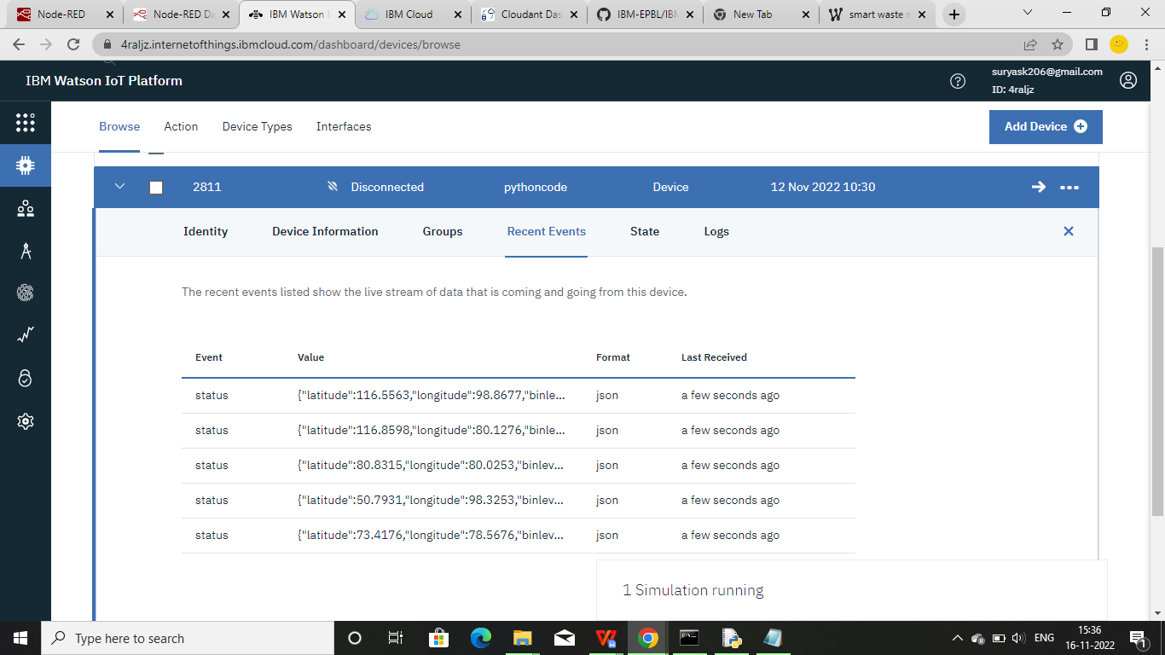

**1. Node-RED Connection setup for data transmission from IBM Watson IOT platform**

**to Node-RED dashboard.**

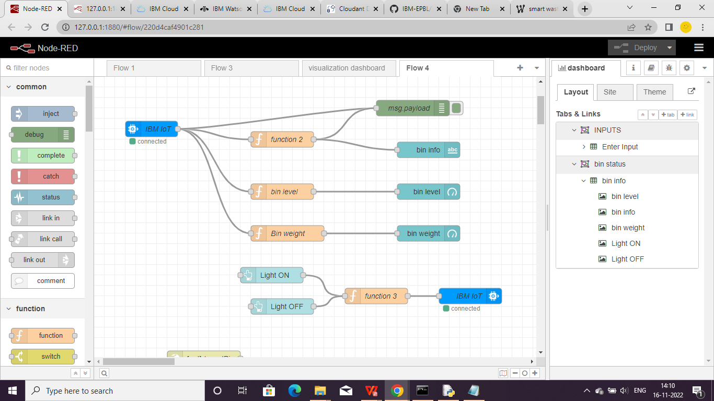

**2. Data transfer from IBM Watson IOT platform and Python IDE to Node red.**

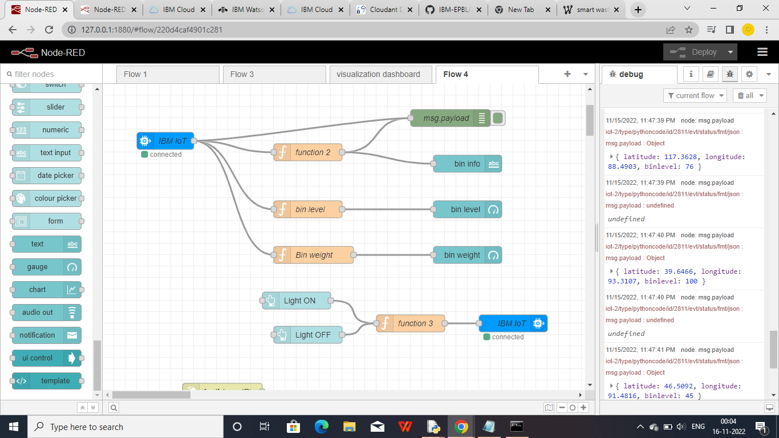

1. **Web ui**

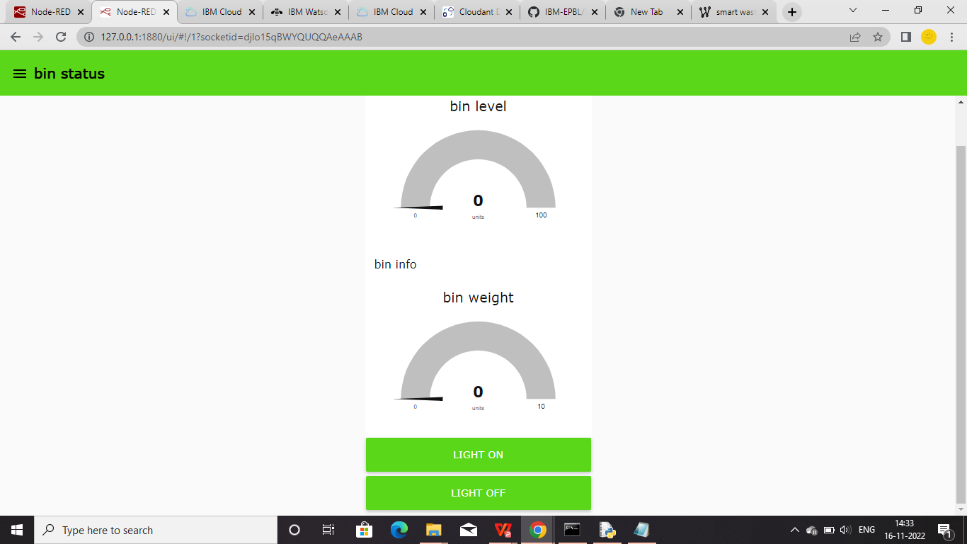

**4 . Storing database in IBM cloudant DB.**

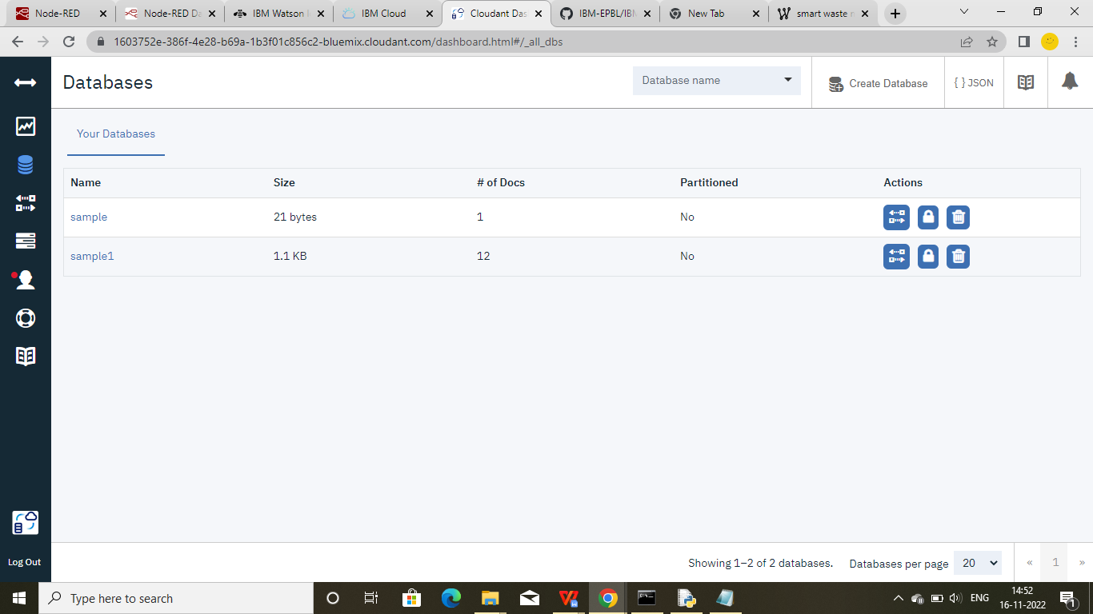

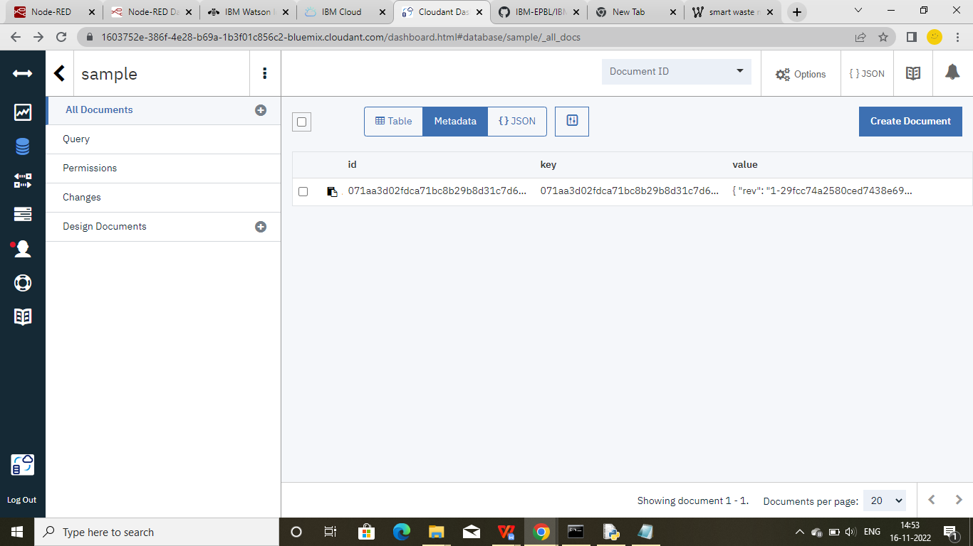

1. **Data is stored in JSON format.**

